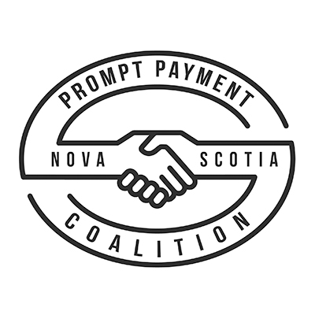
September 13, 2018
[MLA Name]
[MLA Constituency Address 1
Address 2
City, Province, Postal Code]
Dear [MLA Name],
Payment delays are unacceptable in Nova Scotia’s construction industry and we, the Nova Scotia Prompt Payment Coalition, are calling on the provincial government to enact appropriate legislation.
Our province needs a prompt payment solution that works for everyone including tradespeople, contractors, government and consumers. While this serious problem is being felt now in our industry, there is a risk to Nova Scotia’s competitiveness long-term if we do not take action to fix the issue.
The existing law in Nova Scotia – the Builders Lien Act – is costly, cumbersome, and inaccessible to 65 per cent of the construction industry (small and medium-sized family-owned companies consisting of 50 or fewer employees). It addresses non-payment as opposed to delinquent payment and the lien rights of many in the industry will expire long before they realize they will not get paid.

Over the last three years, the Construction Association of Nova Scotia has surveyed its members three times to solicit their feedback on prompt payment. Here are some highlights from the 2018 survey:

- 77% of respondents indicated that delayed payments were occurring most or all of the time on their projects.
- 70% believe that the right legal framework does not exist to improve timeliness of payments.
- 94% indicate that delayed payment increases the cost of doing business
- 67% indicate that delayed payment reducing their ability to bid work and grow their business
- 75% indicated that delayed payment increases the cost of project delivery
- 55% agree or strongly agree that if paid in a more timely manner, their firm would increase the use of apprentices; while 53% indicate they would hire more people
Prompt payment legislation sets out the rights and responsibilities of all parties to a construction project through the establishment of minimum standards for payment, dispute resolution and communication. The Act will set out minimum payment requirements and will have a systematic approach to how money will be released with rights and responsibilities set forth for all parties to a construction project.

If the provincial government enacts legislation, prompt payment will:

- Improve the movement of money in our economy
- Increase fairness and transparency
- Increase efficiency and productivity
- Lower the cost of construction projects, public and private
- Reduce burden on our judicial system
- Drive investment, employment, training, innovation and purchase of equipment (ie. apprentices)
- Increase competition and number of bidders on public work
- Allow contractors to bid more work

Industry is committed to supporting government to enact model legislation that is progressive and responsive. We are asking that government immediately begin to work with our Coalition to formulate and bring forward legislation before the end of 2018.

For more information about prompt payment and the Nova Scotia Prompt Payment Coalition, visit: www.nspromptpayment.ca
Sincerely,
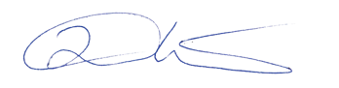
Duncan Williams
President, Construction Association of Nova Scotia
Member, Nova Scotia Prompt Payment Coalition

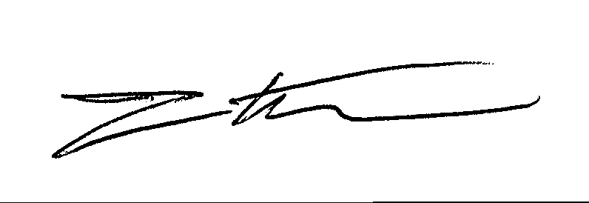
Tim Houtsma, P. Eng.
Board Member, Canadian Steel Institute of Construction
Member, Nova Scotia Prompt Payment Coalition

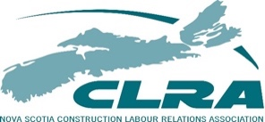
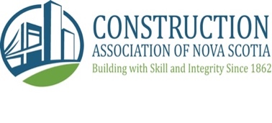

The Nova Scotia Prompt Payment Coalition is a province-wide coalition led by the Construction Association of Nova Scotia and includes contractors, unions, suppliers, general contractors, trade contractors, and anyone else who is invested in working to convince the provincial government to enact appropriate payment legislation that would establish minimum norms for payment schedules.

