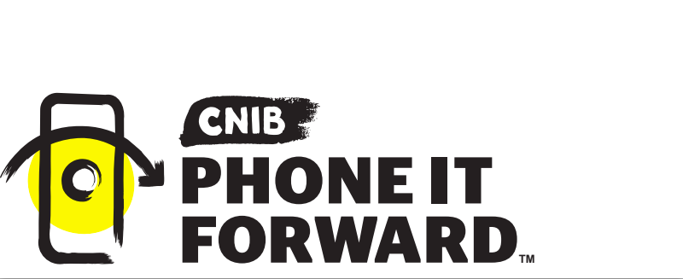

Phone it Forward Corporate Donation Agreement

This Charitable Donation Agreement (this “Agreement”) is made and entered into as of _____________ (the "Effective Date”), by and between ___________ (the “Company") and the Canadian National Institute for the Blind (the “CNIB”), for a charitable donation as described herein (the
"Contribution"). The purpose of this Agreement is to set forth the terms and conditions pursuant to which the Company shall provide and the CNIB shall receive the Contribution.

Background
The CNIB is a charitable organization based in Canada, Charitable Registration Number: 119219459 RR0003. The CNIB is seeking support for their Phone it Forward program, a program that provides life-changing smartphones to people with vision loss who need them. The Company desires to support the CNIB through its Contribution.

The parties hereto agree as follows:
1. The Company shall donate used smart phones to CNIB, as detailed in Exhibit A, which shall be accepted and used by the CNIB consistent with its charitable Phone it Forward program.

2. At a mutually acceptable time and date, but not later than 30 days after the Effective Date, the CNIB will, at the CNIB’s sole cost, expense and risk, accept the Contribution, as identified in Exhibit A to this Agreement, from the Company's offices.

3. Effective upon the CNIB’s acceptance of the Contribution, the Company hereby transfers, assigns and conveys to the CNIB all of the Company’s right, title and interest in and to the Contribution.

4. Upon arrival of the Contribution at the CNIB’s designated processing facility, the CNIB will:-
- Power on device. If device does not power on, log device with product identification and condition, then advance the device to recycling.
- Using software application; check that device does not appear on the list of lost or stolen devices. If device is identified as lost or stolen, quarantine device and advise Company for direction.
- Perform data-wiping on devices*. Software captures erasure key statistics, date/time, and associated IMEI. Devices with passcodes, locks and other security protocols that prohibit data-wiping will be quarantined and reported to Company.
- Appraise the device for wholesale value.

5. After processing of the Contribution, CNIB will provide a report detailing the devices included in the Contribution, as well as a tax receipt for the appraised value of the Contribution, if required, as per Canada Revenue Guidelines.

*Proof of data wiping can be provided if required by the Company.

IN WITNESS WHEREOF, the parties have signed and thereby caused this Agreement to be duly executed effective as of the date written above.

COMPANY CNIB
By: __________________ ____ By: ______________________

Name: ___________________ Name: ___________________

Title: ____________________ Title: ____________________

Date: ____________________ Date: ____________________

EXHIBIT A
DONATED SMARTPHONE SCHEDULE

DETAILED SMARTPHONE INVENTORY DESCRIPTION
If applicable, list any accessories or peripherals.

Make | Model | Quantity

